**MODULE 5 ASSIGNMENT**

**DATA MODIFICATION**

**PROBLEM 4 :**

**1. MODIFICATION STATEMENT :**

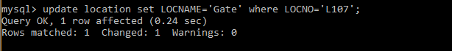

**2. BEFORE THE MODIFCATION STATEMENT :**

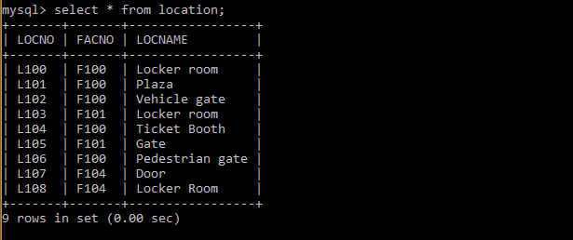

**3. AFTER THE MODIFICATION STATEMENT :**

